# Create A Database In Cloudant DB

|  |  |
| --- | --- |
| Team ID | PNT2022TMID48082 |
| Project Name | Project – Smart Waste Management System For Metropolitan Cities |

***Task:*** *To create a database in Cloudant DB to store location data. Steps followed:*

● Logged in to IBM Cloud account

● Navigated to `./resources`

● Clicked on the “Create

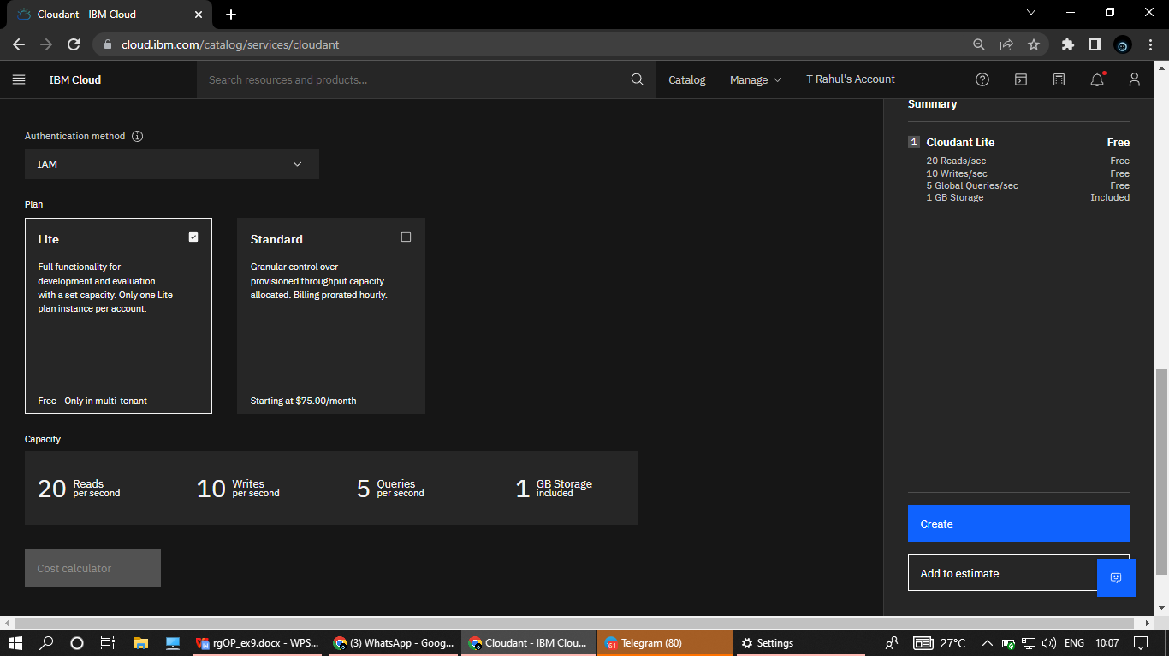

● The Cloudant database resource was created successfully

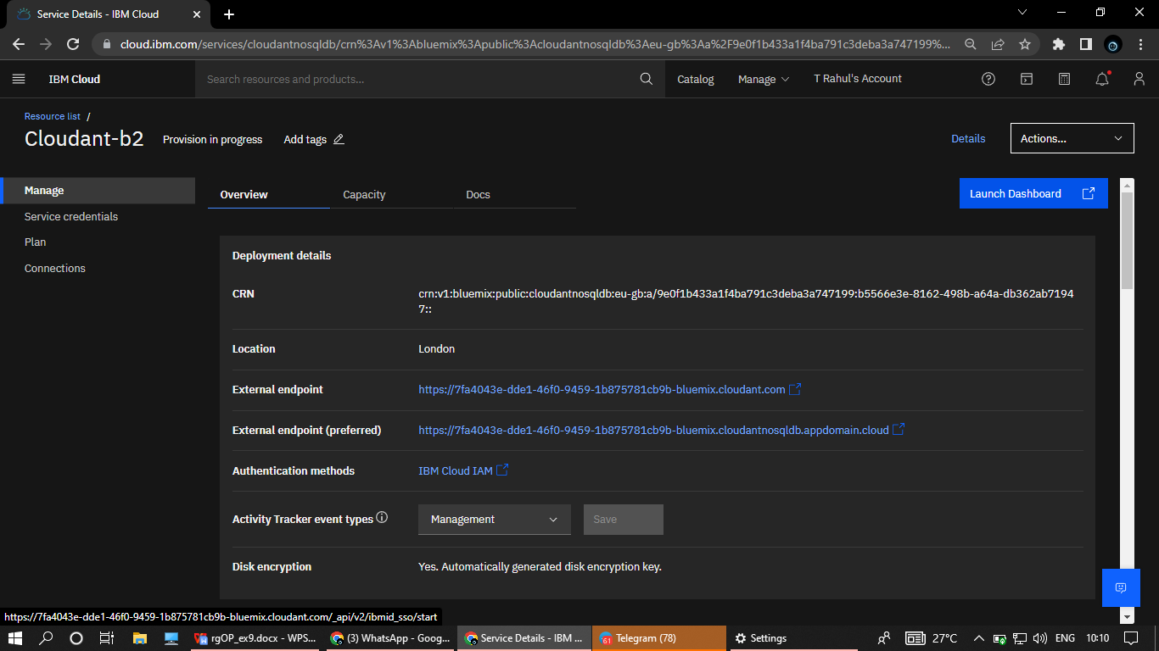

● Clicked on Launch Dashboard & Clicked on “Create Database”. Entered “rahul” as the database name and the “Non-partitioned” option.

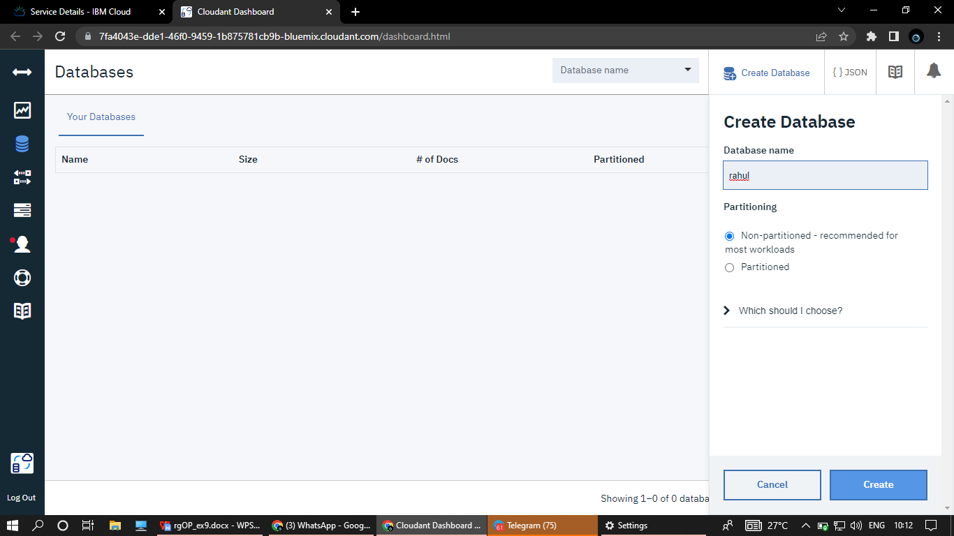

● The database “rahul” was created successfully.

